Learning outcome 3: Ship codes
Definition of general key terms

1.Pull: In Git, "pull" combines two actions: fetching the latest changes from a remote repository and automatically merging them into the current branch. It updates your local branch with the changes made by others and incorporates them into your working copy.
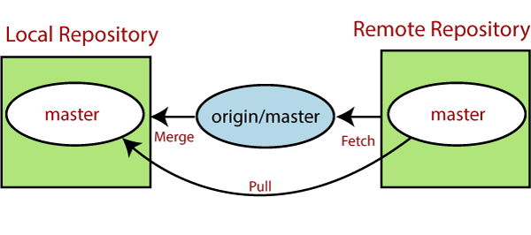

2.Fetch: "Fetch" in Git involves retrieving the latest changes from a remote repository without automatically merging them into the current branch. It allows you to see the changes made by others and decide how to incorporate them into your local branch manually.
3.Push: "Push" in Git means sending your local commits to a remote repository. It updates the remote repository with your changes, making them available to others who are collaborating on the project.
The push term refers to upload local repository content to a remote repository. Pushing is an act of transfer commits from your local repository to a remote repository. Pushing is capable of overwriting changes; caution should be taken when pushing.
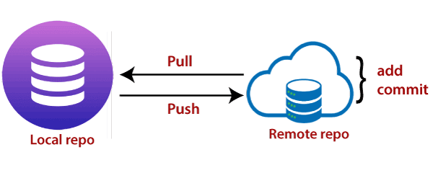
4.Pull Request: Pull requests let you tell others about changes you've pushed to a branch in a repository on GitHub. Once a pull request is opened, you can discuss and review the potential changes with collaborators and add follow-up commits before your changes are merged into the base branch.
Pull request is done when you feel like changing the developer‘s change to another person's code branch.

5.Merge: "Merge" in Git refers to combining the changes from one branch into another branch. It integrates the changes made in one branch into another branch, creating a new commit that incorporates the changes from both branches.
Fetch file from GitHub repository
✔ Operation on git fetch command
● Fetch the remote repository Syntax:
1. $ git fetch< repository Url>

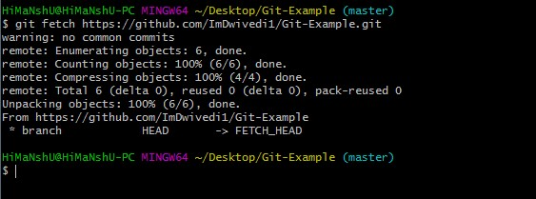

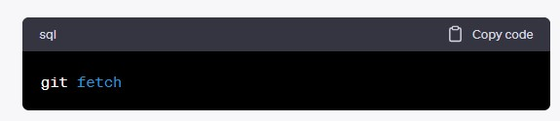
This command retrieves any new changes from the remote repository that you have cloned or
previously fetched. It updates your local copy of the remote branches, allowing you to see the latest
commits and changes made by others.

This command retrieves any new changes from the remote repository that you have cloned or previously fetched. It updates your local copy of the remote branches, allowing you to see the latest commits and changes made by others.

By default, the git fetch command updates all remote branches in your local repository. However, it does not automatically merge or apply those changes to your current working branch. To incorporate the fetched changes into your branch, you can use other Git commands like git merge or git rebase.

Here's an example of how to fetch changes from a remote repository named "origin":
After executing this command, your local repository will be updated with any new commits and
changes from the remote repository. You can then proceed to merge or incorporate those changes into
your current branch as needed
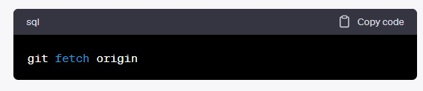

Fetch the specific branch

We can fetch a specific branch from a repository. It will only access the element from a specific branch. See the below output:
Syntax:
1. $ git fetch <branch URL><branch name>
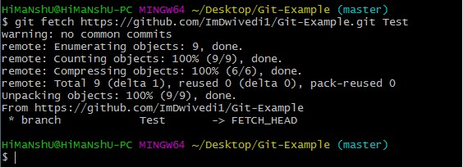

● Fetch all the branch simultaneously
To fetch all the branches simultaneously:
The git fetch command allows to fetch all branches simultaneously from a remote repository. See the below example:
Syntax:
1. $ git fetch -all
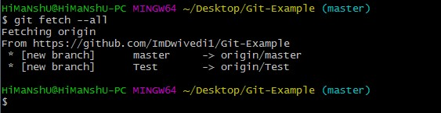
In the above output, all the branches have fetched from the repository Git-Example.

● Synchronize the local repository
To synchronize the local repository:
Suppose, your team member has added some new features to your remote repository. So, to add these updates to your local repository, use the git fetch command. It is used as follows.
Syntax:
1. $ git fetch origin

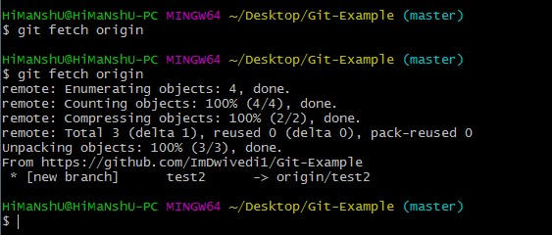
In the above output, new features of the remote repository have updated to my local system. In this output, the branch test2 and its objects are added to the local repository.
The git fetch can fetch from either a single named repository or URL or from several repositories at once. It can be considered as the safe version of the git pull commands.
The git fetch downloads the remote content but not update your local repo's working state. When no remote server is specified, by default, it will fetch the origin remote.

Differences between git fetch and git pull
To understand the differences between fetch and pull, let's know the similarities between both of these commands. Both commands are used to download the data from a remote repository. But both of these commands work differently. Like when you do a git pull, it gets all the changes from the remote or central repository and makes it available to your corresponding branch in your local repository. When you do a git fetch, it fetches all the changes from the remote repository and stores it in a separate branch in your local repository. You can reflect those changes in your corresponding branches by merging.
So basically,
1. git pull = git fetch + git merge

Git Fetch vs. Pull
Some of the key differences between both of these commands are as follows:
git fetch | git pull
Fetch downloads only new data from a remote repository. | Pull is used to update your current HEAD branch with the latest changes from the remote server.
Fetch is used to get a new view of all the things that happened in a remote repository. | Pull downloads new data and directly integrates it into your current working copy files.
Fetch never manipulates or spoils data. | Pull downloads the data and integrates it with the current working file.
It protects your code from merge conflict. | In git pull, there are more chances to create the merge conflict.
It is better to use git fetch  command with git merge command on a pulled repository. | It is not an excellent choice to use git pull if you already pulled any repository.

✔ Operation on git pull

Git Pull / Pull Request

The term pull is used to receive data from GitHub. It fetches and merges changes from the remote server to your working directory. The git pull command is used to pull a repository.



Pull request is a process for a developer to notify team members that they have completed a feature. Once their feature branch is ready, the developer files a pull request via their remote server account. Pull request announces all the team members that they need to review the code and merge it into the master branch.
The below figure demonstrates how pull acts between different locations and how it is similar or dissimilar to other related commands
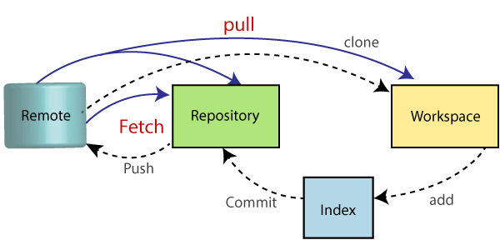
The syntax of the git pull command is given below:
Syntax:
$ git pull <option> [<repository URL><refspec>...]
In which:
- <option>: Options are the commands; these commands are used as an additional option in a particular command. Options can be -q (quiet), -v (verbose), -e(edit) and more.
- <repository URL>: Repository URL is your remote repository's URL where you have stored your original repositories like GitHub or any other git service. This URL looks like:

https://github.com/ImDwivedi1/GitExample2.git

To access this URL, go to your account on GitHub and select the repository you want to clone. After that, click on the clone or download option from the repository menu. A new pop up window will open, select clone with https option from available options. See the below screenshot:

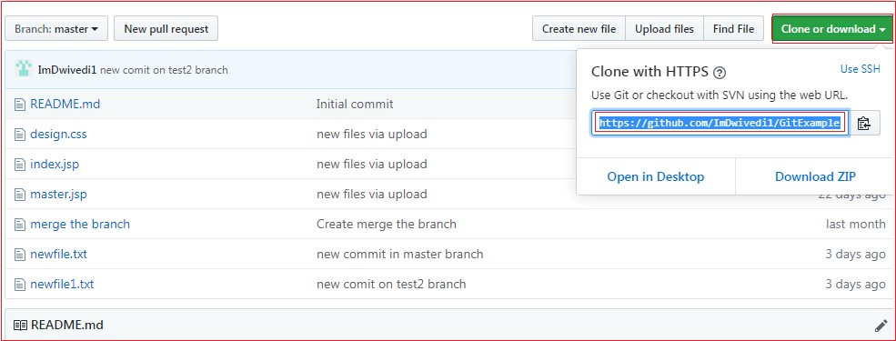

Copy the highlighted URL. This URL is used to Clone the repository.
<Refspec>: A ref is referred to commit, for example, head (branches), tags, and remote branches. You can check head, tags, and remote repository in .git/ref directory on your local repository. Refspec specifies and updates the refs.
How to use pull:
It is essential to understand how it works and how to use it. Let's take an example to understand how it works and how to use it. Suppose I have added a new file say design2.css in my remote repository of project GitExample2.

To create the file first, go to create a file option given on repository sub-functions. After that, select the file name and edit the file as you want. Consider the below image.
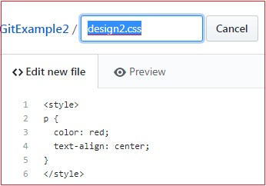

Go to the bottom of the page, select a commit message and description of the file. Select whether you want to create a new branch or commit it directly in the master branch. Consider the below image:

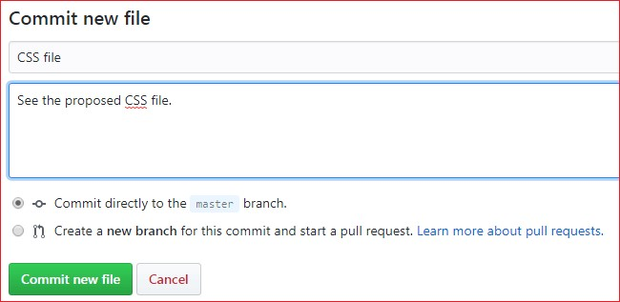

Now, we have successfully committed the changes.
To pull these changes in your local repository, perform the git pull operation on your cloned repository. There are many specific options available for pull command. Let's have a look at some of its usage.

Default git pull:
We can pull a remote repository by just using the git pull command. It's a default option. Syntax of git pull is given below:
Syntax:
$ git pull

Output:
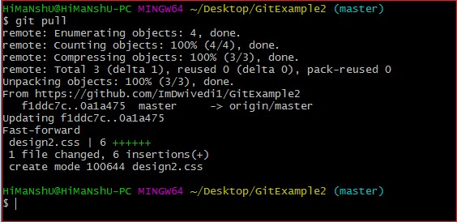

In the given output, the newly updated objects of the repository are fetched through the git pull command. It is the default version of the git pull command. It will update the newly created file design2.css file and related object in the local repository. See the below image

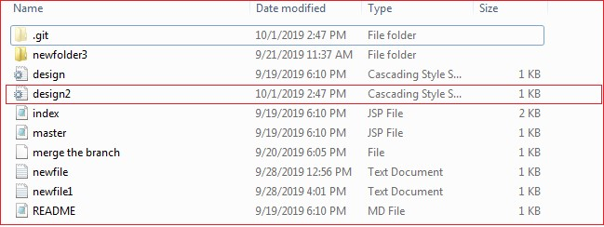

As you can see in the above output, the design2.css file is added to the local repository. The git pull command is equivalent to git fetch origin head and git merge head. The head is referred to as the ref of the current branch.

Git Pull Remote Branch
Git allows fetching a particular branch. Fetching a remote branch is a similar process, as mentioned above, in git pull command. The only difference is we have to copy the URL of the particular branch we want to pull. To do so, we will select a specific branch. See the below image:

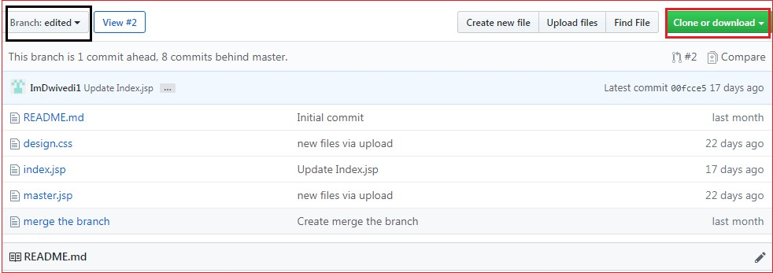

In the above screenshot, I have chosen my branch named edited to copy the URL of the edited branch. Now, I am going to pull the data from the edited branch. Below command is used to pull a remote branch:

Syntax:
$ git pull <remote branch URL>
Output:
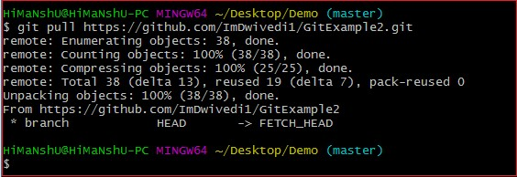
In the above output, the remote branch edited has copied.

● Git force pull

Git force pull allows for pulling your repository at any cost. Suppose the below scenario:
If you have updated any file locally and other team members updated it on the remote. So, when will you fetch the repository, it may create a conflict.
We can say force pull is used for overwriting the files. If we want to discard all the changes in the local repository, then we can overwrite it by influentially pulling it. Consider the below process to force pull a repository:
Step1: Use the git fetch command to download the latest updates from the remote without merging or rebasing.
$ git fetch –all
Step2: Use the git reset command to reset the master branch with updates that you fetched from remote. The hard option is used to forcefully change all the files in the local repository with a remote repository.
$ git reset -hard <remote>/<branch_name>
$ git reset-hard master

Consider the below output:
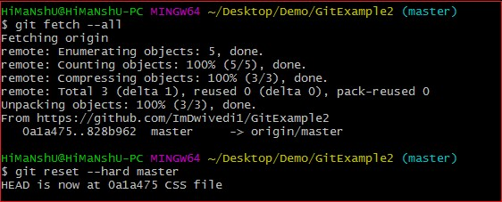

In the above output, I have updated my design2.css file and forcefully pull it into the repository.

Git pull origin master

There is another way to pull the repository. We can pull the repository by using the git pull command. The syntax is given below:
$ git pull <options><remote>/<branchname>
$ git pull origin master
In the above syntax, the term origin stands for the repository location where the remote repository situated. Master is considered as the main branch of the project.
Consider the below output:
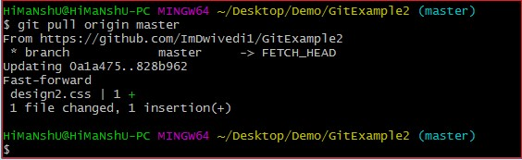

It will overwrite the existing data of the local repository with a remote repository.
You can check the remote location of your repository. To check the remote location of the repository, use the below command:
$ git remote -v
The given command will result in a remote location like this:
origin https://github.com/ImDwivedi1/GitExample2 (fetch) origin https://github.com/ImDwivedi1/GitExample2 (push)
The output displays fetch and push both locations. Consider the below image:

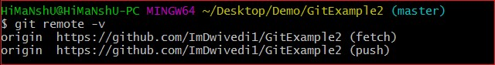

● Push files to remote branch

Git Push
The push term refers to upload local repository content to a remote repository. Pushing is an act of transfer commits from your local repository to a remote repository. Pushing is capable of overwriting changes; caution should be taken when pushing.

✔ Tags used on git push command

Git Push Tags
<repository>: The repository is the destination of a push operation. It can be either a URL or the name of a remote repository.
<refspec>: It specifies the destination ref to update source object.
--all: The word "all" stands for all branches. It pushes all branches.
--prune: It removes the remote branches that do not have a local counterpart. Means, if you have a remote branch say demo, if this branch does not exist locally, then it will be removed.
--mirror: It is used to mirror the repository to the remote. Updated or Newly created local refs will be pushed to the remote end. It can be force updated on the remote end. The deleted refs will be removed from the remote end.
--dry-run: Dry run tests the commands. It does all this except originally update the repository.
--tags: It pushes all local tags.
--delete: It deletes the specified branch.
-u: It creates an upstream tracking connection. It is very useful if you are going to push the branch for the first time.

✔ operation on git push

● push on origin master
Git push origin master is a special command-line utility that specifies the remote branch and directory. When you have multiple branches and directory, then this command assists you in determining your main branch and repository.
Generally, the term origin stands for the remote repository, and master is considered as the main branch. So, the entire statement "git push origin master" pushed the local content on the master branch of the remote location.
Syntax:
1. $ git push origin master
Let's understand this statement with an example.
Let's make a new commit to my existing repository, say GitExample2. I have added an image to my local repository named abc.jpg and committed the changes. Consider the below image:

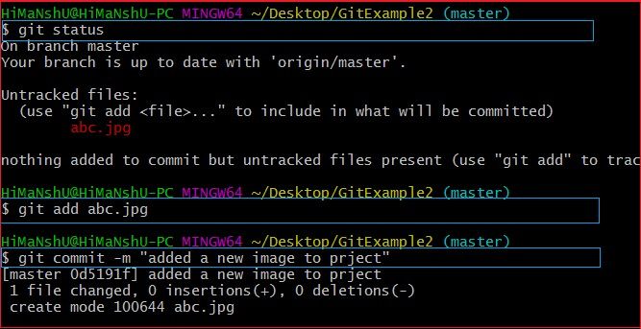

In the above output, I have attached a picture to my local repository. The git status command is used to check the status of the repository. The git status command will be performed as follows:
$ git status
It shows the status of the untracked image abc.jpg. Now, add the image and commit the changes as:
$ git add abc.jpg
$git commit -m "added a new image to project."
The image is wholly tracked in the local repository. Now, we can push it to origin master as:
$ git push origin master Output:
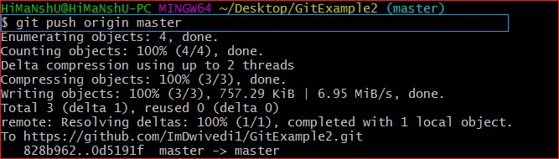

The file abc.jpg is successfully pushed to the origin master. We can track it on the remote location. I have pushed these changes to my GitHub account. I can track it there in my repository. Consider the below image:
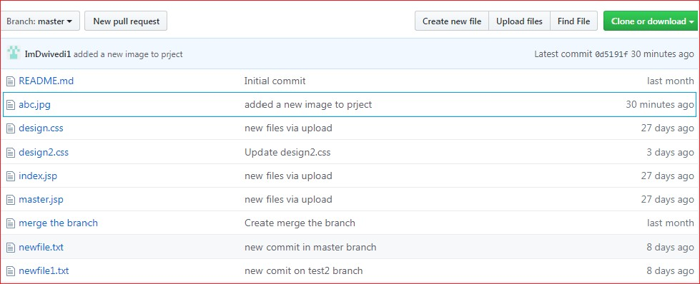
In the above output, the pushed file abc.jpg is uploaded on my GitHub account's master branch repository.

● git push force

Git Force Push
The git force push allows you to push local repository to remote without dealing with conflicts. It is used as follows:
1. $ git push <remote><branch> -f
Or
1. $ git push <remote><branch> -force
The -f version is used as an abbreviation of force. The remote can be any remote location like GitHub, Subversion, or any other git service, and the branch is a particular branch name. For example, we can use git push origin master -f.
We can also omit the branch in this command. The command will be executed as:
1. $git push <remote> -f

We can omit both the remote and branch. When the remote and the branch both are omitted, the default behavior is determined by push.default setting of git config. The command will be executed as:
1. $ git push -f

How to Safe Force Push Repository:
There are several consequences of force pushing a repository like it may replace the work you want to keep. Force pushing with a lease option is capable of making fail to push if there are new commits on the remote that you didn't expect. If we say in terms of git, then we can say it will make it fail if remote contains untracked commit. It can be executed as:
1. $git push <remote><branch> --force-with-lease

● git push verbose Git push -v/--verbose
The -v stands for verbosely. It runs command verbosely. It pushed the repository and gave a detailed explanation about objects. Suppose we have added a newfile2.txt in our local repository and commit it. Now, when we push it on remote, it will give more description than the default git push. Syntax of push verbosely is given below:
Syntax:
1. $ git push -v
Or
1. $ git push --verbose

Consider the below output:

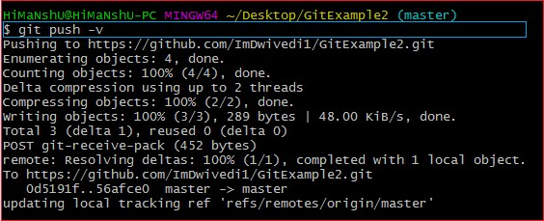
If we compare the above output with the default git option, we can see that git verbose gives descriptive output.

● delete a remote branch

We can delete a remote branch using git push. It allows removing a remote branch from the command line. To delete a remote branch, perform below command:
Syntax:
1. $ git push origin -delete edited

Output:
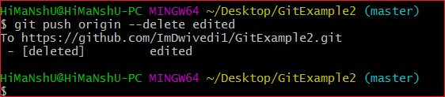

In the above output, the git push origin command is used with -delete option to delete a remote branch. I have deleted my remote branch edited from the repository. Consider the below image:
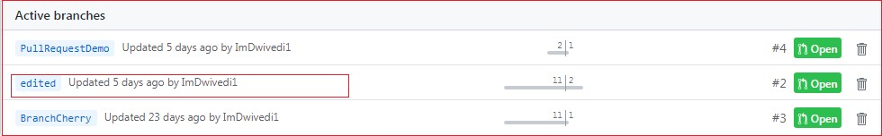
It is a list of active branches of my remote repository before the operating command.
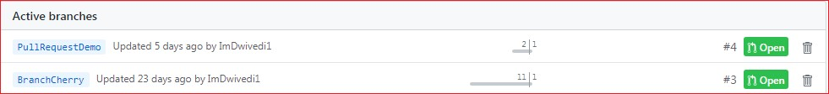

The above image displays the list of active branches after deleting command. Here, you can see that the branch edited has removed from the repository.

